OSINT LAB TASK
Sherlock & theHarvester

Areesha Raheel
55039
BSIT-5

Installing Sherlock
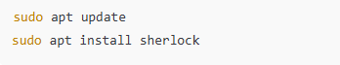
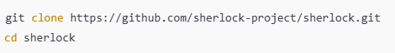

Create virtual environment
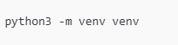

Activate the virtual environment
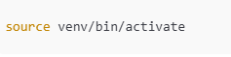

Changed to something like this
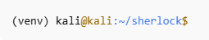

SCREENSHOTS:
